|  |
| --- |
| Rename method |

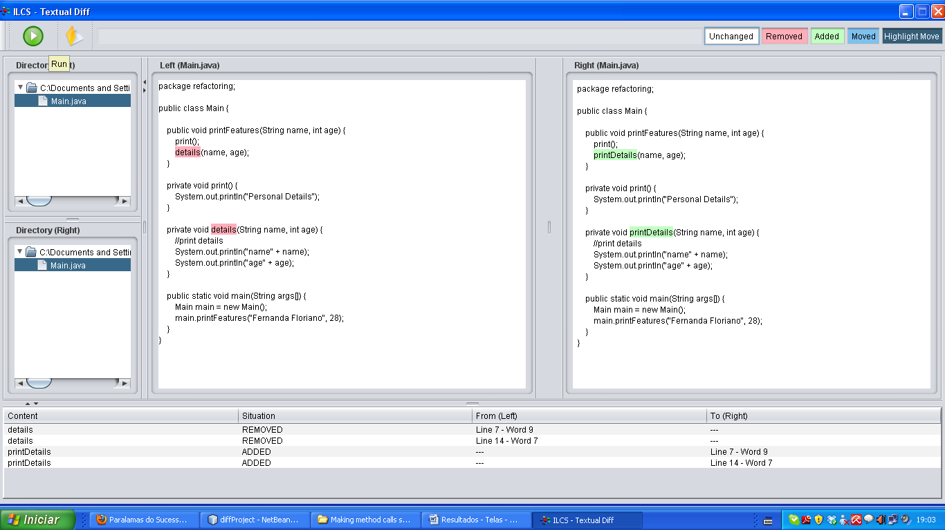

Com granularidade caracter

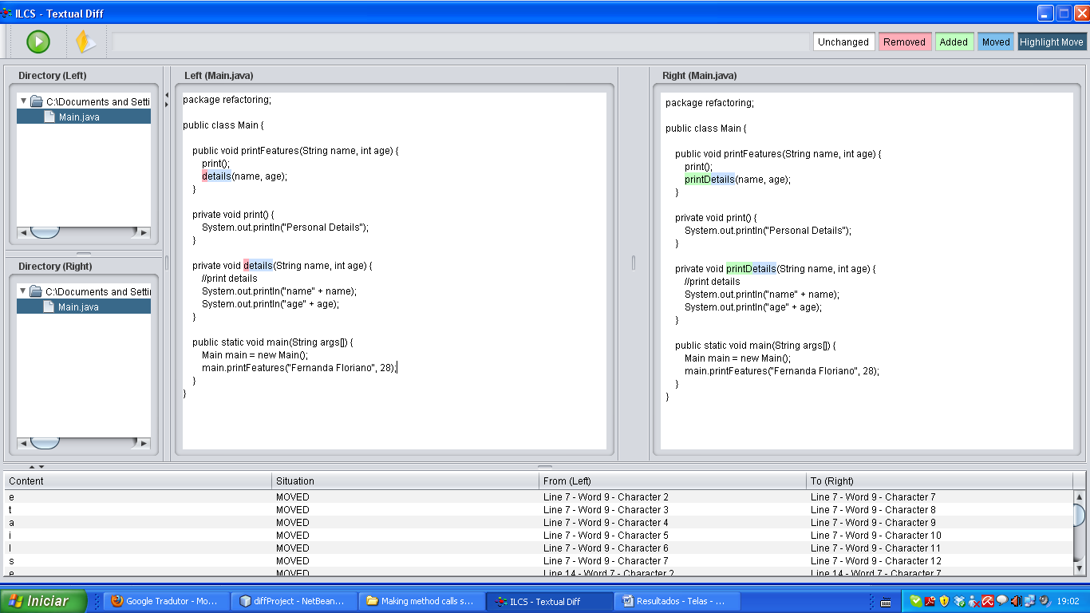

|  |
| --- |
| Add parameters |

|  |
| --- |
| Remove parameter |

|  |
| --- |
| Separate query from modifier |

|  |
| --- |
| Parameterize method |

|  |
| --- |
| Replace parameter with explicit methods |

|  |
| --- |
| Preserve whole object |

|  |
| --- |
| Replace parameter with method |

|  |
| --- |
| Introduce parameter object |

|  |
| --- |
| Remove setting method |

|  |
| --- |
| Hide method |

|  |
| --- |
| Replace constructor with factory method |

|  |
| --- |
| Encapsulate downcast |

|  |
| --- |
| Replace error code with exception |

|  |
| --- |
| Replace exception with test |